THEBERTON & EASTBRIDGE NEWSLETTER
OCTOBER 2019

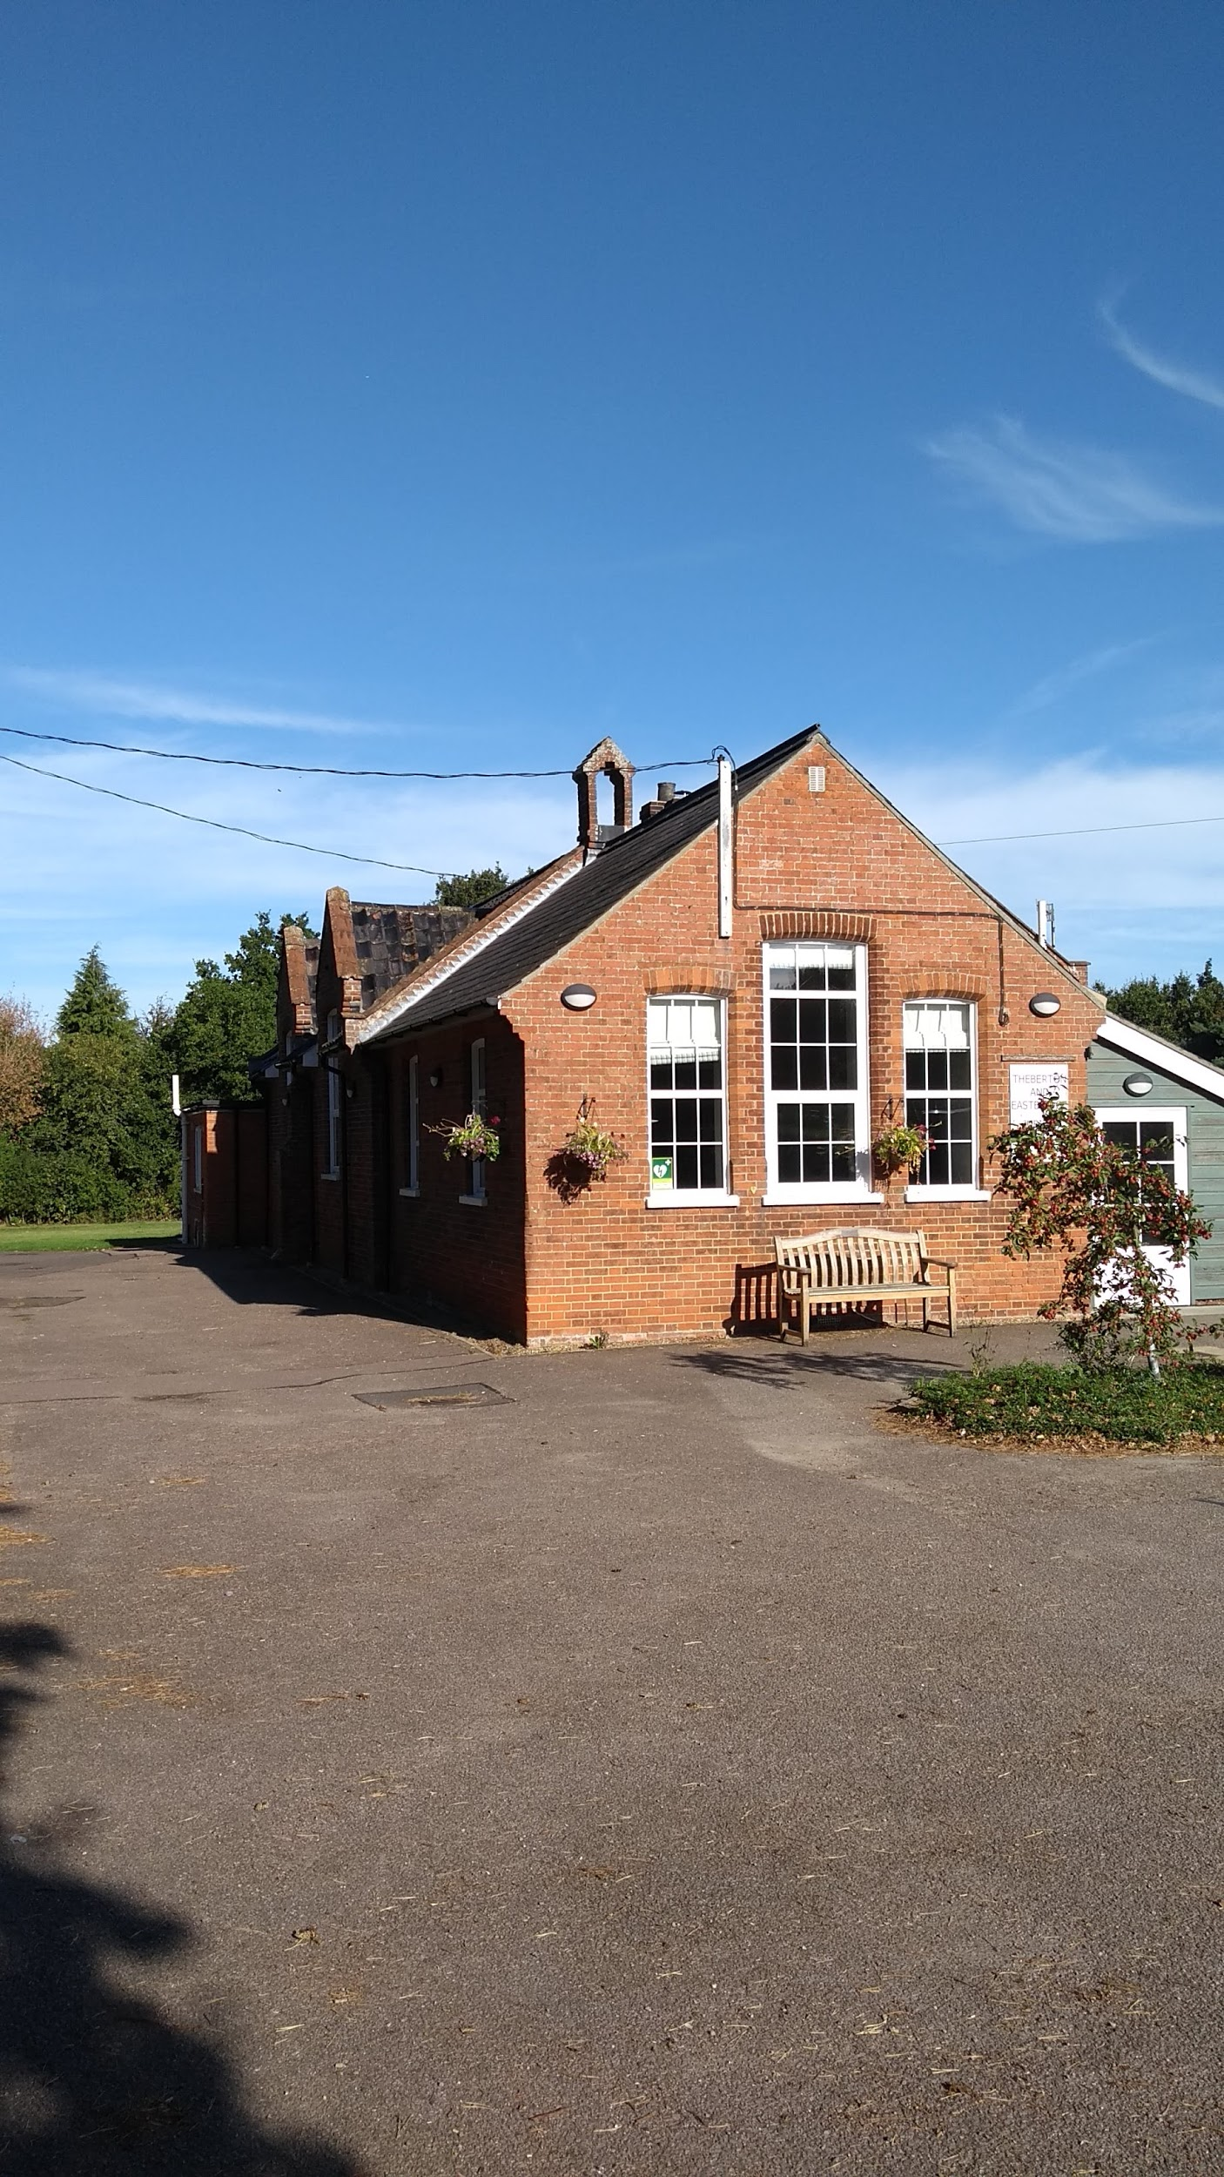
Community Council events:
Calling all volunteers!

Jubilee Hall Maintenance Day on Saturday 19th October from 9:30am

People are asked to bring rakes, brooms, garden gloves etc.

The bonfire for fireworks night will start being built from 1st October at the Theberton playing field. Feel free to add burnable garden rubbish - nothing dangerous please.

The ever popular Quiz night with buffet and prize draw is back on Sunday 6th October at 7pm at the Jubilee Hall. £5 per person - teams of six. Bring your own drink. To book your table, ring Ronnie on 831571.

On Saturday 26th October grab a bargain at the Jumble sale 2pm at Jubilee Hall. Any jumble can be left at the hall on Friday 25th October or ring Ronnie 831571.

Fireworks night is to be held on Saturday 2nd November starting at 6:30pm at the Theberton playing field. Hot dogs and soup afterwards in Jubilee Hall.

Middleton Primary School PTA: are inviting the community to a Ladies Night - an evening of empowering fun and information at the Jubilee Hall on Friday 4th October. 7pm reception for a 7:30pm start for an evening that includes a reception glass of wine and a two course supper. £15 tickets available from the Lion or calling 01728 635 736. Monies raised are for school PTA and EACH (East Anglia Children’s Hospice).

Yoga at Jubilee Hall: Newcomers are welcome to join at any time. Sessions run on Tuesday for beginners 9-10am, Intermediates Tuesday and Wednesday 10.15am-11.45am. Fees payable termly. For further details, call Judie Shore 01728 648460.

Theberton church Christmas Concert: Plans are now underway for the Christmas concert to coincide with the church’s Christmas Tree festival. Come and join us while having some fun. We are hoping to have a choir to lead the singing of Christmas songs at the concert set amongst the trees. We did this a couple of years ago and great fun was had by all. If you are happy to join in, contact Tina by either phone 01728 830237 or email tina.neal@sky.com

Xmas Tree Festival: This year's Festival will be held on Saturday 7th and Sunday 8th December from 11.00am to 4.00pm. Every year the display in the church gets better and better and Joan would like to thank you all for your support over the last ten years and your amazing trees. If you are new to the village and would like to know more, please feel free to give Joan a ring for more details. Trees of all sizes from 12 inches to 6ft are included in the festival, so don't think you have to provide a large tree. It doesn't seem possible we are talking about Christmas already but it's time to get your thinking caps on and confirm your participation with Joan (tel: 830710). There will be a Christmas Bazaar in the hall on the same weekend with stalls and lunches. Please contact Ronnie if you are able to help (831571)

Free horse muck: If anyone would like free horse muck for their garden to please email or message Emma at kicheche6benja@gmail.com or 07746 114645
Dates for the diary: October

Mon 2nd The Lion 9pm Quiz Night
Fri 4th Jubilee Hall 7pm Middleton Primary School PTA Ladies Night
Sat 5th The Lion 9pm Karaoke
Sun 6th Jubilee Hall 7pm Quiz Night with buffet and prize draw
Mon 7th The Lion 8:30pm Beer Club
Wed 9th The Lion 9pm Quiz Night
Mon 14th The Lion 8pm Open Mic Night
Wed 16th The Lion 9pm Quiz Night
Thur 17th The Lion 7:30pm Women’s Group
Sat 19th Jubilee Hall 9:30am Jubilee Hall Maintenance Day
Sat 19th The Lion 9pm Rock & Roll Bingo
Mon 21st The Lion 7pm Reading between the wines Book Club
Wed 23rd The Lion 9pm Quiz Night
Sat 26th Jubilee Hall 2pm Jumble Sale
Sat 26th The Lion 8pm Halloween Party - Live Music from Claire Free
1st Annual Theberton Lion Gin Festival
Wed 30th The Lion 9pm Quiz Night

If you wish to include details of a regular event/ club in the Theberton or Eastbridge area in the newsletter, please email details to:
thebertoneastbridgenews@gmail.com

